ESP/Mind-Reading Show
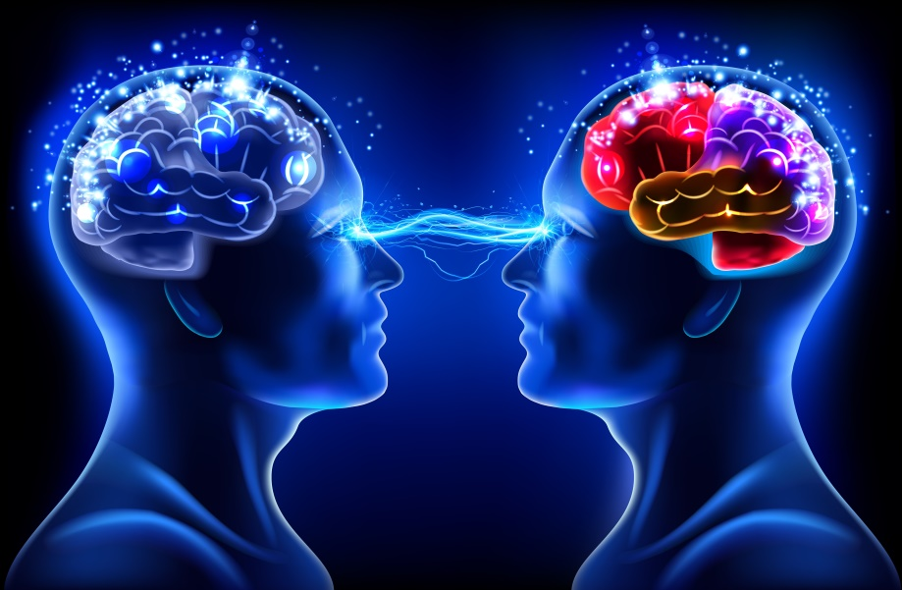
During this 60 minute show, will be looking at some of these questions and seeing if we can find answers to some of them.
What is E.S.P and do you have it?
Can you communicate your thoughts to others telepathically?
Do you have a 6th Sense and can you tap into it?
Is it possible for someone else to read your mind?
Recently Mark Zukerberg said “The future of Facebook is Telepathy” .
It is also said that “Everyone is born with a psychic ability, it’s just a question of tapping into it”.
If you answer “Yes” to one or more of the following questions you may have this ability.
“Ever thought of someone and the phone rings and they are on the other end of the line or you bump into them?”
“Ever thought of a song and it begins to play on the radio?”
“Ever had a premonition, an omen or a hunch about something that came true?”
“Ever had a Deja Vu experience?”
During the show members of the audience will be invited to come onto the stage and take part in various demonstrations, using everyday objects such as coins, dice, colour pens, cards, watches etc to see if they have these capabilities and if it’s possible to unlock them. The results are profound and you will be talking about what you have witnessed for weeks to come.

“We would like to express our sincere thanks for last Friday night. Your act was certainly one of the highlights of the night. People have talked of little else! It was a delight to have your act in the middle of the evening and was enjoyed by everyone”
Helen Belton OGT Organising Committee.

We can either do Close Up Magic before or after the show. For a couple of hours we charge £400. For more details about Close Up Magic please see below
Close Up Magic is a wonderful form of entertainment that can be held at banquets, wedding and receptions. It can be done at the initial reception (where Simon Mix and Mingles with the guests) or when guests are seated at their tables where Simon table hops from table to table. Having won the title of South London Close Up Champion three times, Simon sets the room alight as he astonishes guests with his fun, friendly & interactive magic, which happens right before your very eyes and often in your hands.

Rabbits multiply, rings vanish, rope is cut and restored, cards float and there is also some Mind Reading and ESP, along with his famous Money Making Machine. A great time is had by one and all. Laughter and applause follow him around the room and Simon helps cut the ice by making the guests relax and enjoy themselves. Long after the event they are often talking about the magic and entertainment, ensuring that your event becomes truly special and memorable.
“Just a quick note to thank you on behalf of Rachael and myself for a fantastic performance at Chapter One. We had a great time – as did all our guests. Thanks once again – I know all my friends were impressed and hope to see you again at my 50th!!” All the best Nick (40) and Rachel

“Many thanks for the performance on Wednesday. The Christmas Reception was one of the best yet!!” Major Energy Users Council

